MEGHNAD SAHA INSTITUTE OF TECHNOLOGY

*Techno Complex, Madurdaha,Beside NRI Complex, Post-Uchhepota, Kolkata 700 150*

LABORATORY NOTE BOOK

MAKAUT EVEN SEMESTER 2025



[MASTERS OF COMPUTER APPLICATION]

[OBJECT ORIENTED PROGRAMMING LAB USING JAVA (MCAN-293)]

[RUPAK SARKAR]

ROLL NO: 14271024036 REGN. NO.: 241420510045

STREAM: MCA SEMESTER: II (2ND)

YEAR: 1ST YearSESSION: 2024-2026



MAULANA ABUL KALAM AZAD UNIVERSITY OF TECHNOLOGY



MEGHNAD SAHA INSTITUTE OF TECHNOLOGY

*Techno Complex,. Madurdaha,Beside NRI Complex, Post-Uchhepota, Kolkata 700 150*

“LIST OF ASSIGNMENT/EXPERIMENT SUBMISSION DETAILS”

|  |  |  |  |  |  |
| --- | --- | --- | --- | --- | --- |
| **SL.**  **NO.** | **ASSIGNMENT / EXPERIMENT NAME** | **DATE OF EXPERIMENT** | **DATE OF SUBMISION** | **CHECKED BY** | **REMARKS (ANY DEVIATION REGARDING SUBMISSION DATES, CONTENT, FORMAT, ETC)** |
| 1. | Describe Static keyword using example. | 10/03/2025 | 17/03/2025 |  |  |
| 2. | Create a Bank Account class and apply different functions. | 10/03/2025 | 17/03/2025 |  |  |
| 3. | Create a variable size Stack using user input. | 10/03/2025 | 17/03/2025 |  |  |
|  |  |  |  |  |  |
|  |  |  |  |  |  |
|  |  |  |  |  |  |
|  |  |  |  |  |  |
|  |  |  |  |  |  |
|  |  |  |  |  |  |
|  |  |  |  |  |  |

|  |
| --- |
| OBSERVATIONS / COMMENTS ON THE OVERALL PERFORMANCE: |

Signature in full with date Signature in full with date

**Faculty / Technical Assistant Lab Examiner**

**Q.1. Describe Static keyword using a proper example.**

**Code:**

class StaticDemo

{

    static int a=3;

    static int b;

    static void meth(int x)

    {

        System.out.println("x: "+x);

        System.out.println("a: "+a);

        System.out.println("b: "+b);

    }

    static

    {

        System.out.println("Static block initialized");

        b=a*4;

    }

    public static void main(String args[])

    {

        meth(42);

    }

}

**Output:**

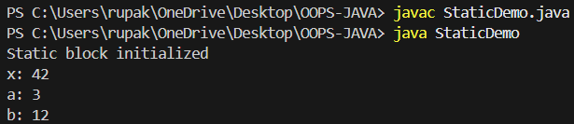

**Q.2.Use a class bank account that contains - AC holder name, amount deposited, amount withdrawal, balance. Create a Static variable that'll count the total no of accounts created, getcount() function will display the total count. (The function should be Static also).**

**Code:**

class Account

{

    String name;

    double balance;

    static int count = 0;

    static int getCount()

    {

        return count;

    }

    Account(String n, double b)

    {

        name = n;

        balance = b;

        count++;

        System.out.println("The account is created! " + name + " with balance: " + balance);

    }

    void deposit(double deposit)

    {

        balance += deposit;

        System.out.println(name + " deposited " + deposit + ". New balance: " + balance);

    }

    void withdraw(double amt)

    {

        if (amt < 1000)

        {

            System.out.println("Amount can't be withdrawn. Minimum withdrawal is 1000.");

        } else if (amt > balance) {

            System.out.println("Insufficient balance!");

        } else {

            balance-=amt;

            System.out.println(name + " withdrew " + amt + ". New balance: " + balance);

        }

    }

    void display()

    {

        System.out.println("Account holder: " + name + ", Balance: " + balance);

    }

}

class AccDemo

{

    public static void main(String args[])

    {

        System.out.println();

        Account a1 = new Account("Rain", 10000);

        a1.withdraw(1000);

        System.out.println();

        a1.display();

        a1.deposit(2000);

        System.out.println();

        a1.display();

        System.out.println("Total accounts created: " + Account.getCount());

    }

}

**Output:**

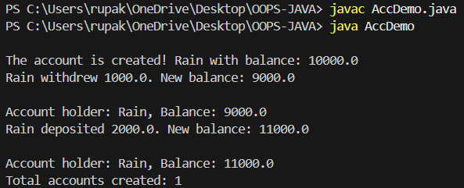

**Q.3. Create a variable size Stack (Size is user input).**

**Code:**

import java.util.Scanner;

class Stack2 {

    private int[] stack;

    private int top = -1;

    public Stack2(int size) {

        stack = new int[size];

    }

    public void push(int value) {

        if (top == stack.length - 1)

            System.out.println("Stack Overflow!");

        else

            stack[++top] = value;

    }

    public void pop() {

        if (top == -1)

            System.out.println("Stack Underflow!");

        else

            System.out.println("Popped: " + stack[top--]);

    }

    public void display() {

        if (top == -1)

            System.out.println("Stack is empty.");

        else

            for (int i = top; i >= 0; i--) System.out.println(stack[i]);

    }

    public static void main(String[] args) {

        Scanner sc = new Scanner(System.in);

        System.out.print("Enter stack size: ");

        Stack2 stack = new Stack2(sc.nextInt());

        stack.push(10);

        stack.push(20);

        stack.display();

        stack.pop();

        stack.display();

        sc.close();

    }

}

**Output:**

